𝗡𝗮𝗺𝗲: Saheshwari Baghmar
𝗦𝘁𝘂𝗱𝗲𝗻𝘁 𝗜𝗗: CA/SE1/26559
-𝗗𝗼𝗺𝗮𝗶𝗻: Biotechnology
Batch: 1/11/25 to 30/11/25

Research Report

Recent Advancements in Biotechnology: CRISPR ene Editing
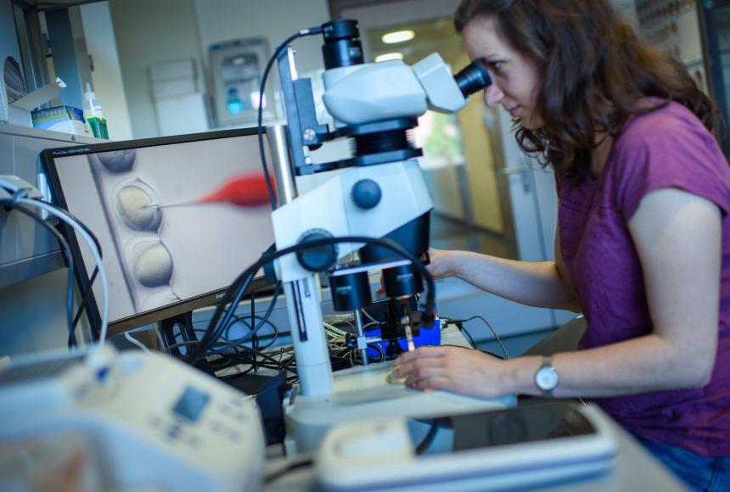

1. Introduction
Biotechnology has transformed modern science by offering tools to manipulate genetic material with precision. Among the greatest breakthroughs is CRISPR-Cas9, a genome-editing technology that allows researchers to cut, modify, or replace DNA sequences. Originally discovered as a bacterial immune defense system, CRISPR has now become a revolutionary tool in gene therapy, agriculture, diagnostics, and drug discovery.

This report explores recent advancements, major applications, benefits, limitations, and future directions of CRISPR technology.

2. What is CRISPR?
CRISPR stands for Clustered Regularly Interspaced Short Palindromic Repeats. It is part of a bacterial defense mechanism where bacteria store fragments of viral DNA to recognize and destroy future infections.

Components
Cas9 enzyme: Molecular “scissors” that cut DNA.

Guide RNA (gRNA): Directs Cas9 to the exact target sequence.

When the cut is made, the cell repairs the DNA, enabling scientists to insert or delete genetic material.
3. Recent Advancements in CRISPR Technology

3.1 Base Editing (BE)

Developed in 2016, base editing allows scientists to modify a single DNA letter (A, T, G, C) without cutting the DNA.
Benefits:
Reduces errors
High precision

Useful in correcting point mutations (responsible for 60% of genetic diseases)

3.2 Prime Editing

Prime editing is known as the “CRISPR 2.0” system.
It can:
Insert DNA
Delete DNA

Replace DNA sequences
with far fewer off-target effects.

It is capable of correcting up to 89% of known genetic mutations.

3.3 CRISPR-Cas12 & Cas13 Systems

Cas12: Cuts DNA with higher flexibility

Cas13: Targets RNA, not DNA—useful for viral infections.

These tools enable diagnostics and antiviral therapies.

3.4 CRISPR Diagnostics
Platforms like SHERLOCK and DETECTR provide rapid, affordable tests for:

COVID-19
Dengue
Zika

Tuberculosis
These tests work in 30 minutes and require no complex lab setup.

3.5 CRISPR Gene Therapy Trials

Recent human clinical trials using CRISPR include treatments for:

Sickle Cell Disease (first FDA-approved CRISPR therapy: Exa-cel, 2023)

Beta-thalassemia

Leber Congenital Amaurosis (blindness).
Transthyretin amyloidosis
Results show dramatic improvements, marking the start of genetic cures.

3.6 CRISPR in Cancer Research

CAR-T cell engineering
CRISPR-modified immune cells
Improved cancer drug discovery

CRISPR
allows scientists to systematically “delete” genes in cancer cells to identify targets for new therapies.

4. Applications of CRISPR in Biotechnology

4.1 Medical Biotechnology
Correcting genetic disorders (e.g., cystic fibrosis, muscular dystrophy).
Engineering immune cells to fight cancer.

Treating viral diseases by cutting viral genomes.
Developing personalized medicine.

4.2 Agricultural Biotechnology
Disease-resistant crops
Drought-tolerant plants
Improved nutritional content
Faster crop breeding.

Example:
CRISPR-edited rice resistant to bacterial blight is already in field trials.

4.3 Industrial Biotechnology

Engineering microbes for enzyme production
Designing bacteria for biofuel synthesis
Editing yeast for efficient fermentation
Producing biodegradable plastics
4.4 Environmental Biotechnology
Gene drives for mosquito population control
Bioremediation using engineered microbes
Reducing methane emissions from cattle using edited gut bacteria

---

5. Advantages of CRISPR
High precision

Low cost (10× cheaper than older tools like TALENs)

Fast editing (takes hours instead of weeks)

Scalable for industrial use

Versatile (DNA, RNA, bacteria, plants, animals, human cells)

6. Ethical, Social, and Safety Concerns

6.1 Off-target mutations
Accidental edits may cause unintended genetic changes.

6.2 Germline Editing
Editing embryos raises moral concerns because changes are inherited.

6.3 Designer Babies
Fear of misusing CRISPR for non-medical enhancements.

6.4 Environmental risks
Gene drives might affect ecosystems if released without control.

6.5 Access and equity
Advanced gene therapies may be expensive initially.

---

7. Future Prospects

CRISPR is expected to:
Cure more genetic diseases
Reduce food insecurity

Create sustainable biofuels
Enable programmable cells & synthetic organs.
Transform personalized medicine
Develop CRISPR pills & injections for simple treatments.

Upcoming technologies:

CRISPR 3.0 (Casɸ) — tiny enzyme from bacteriophages.
Molecular Recording Systems that store cellular memories.
Epigenome Editing without changing DNA sequence.
The global CRISPR market is projected to reach $10 billion by 2030.

8. Conclusion

CRISPR-Cas gene editing stands as one of the most revolutionary advancements in biotechnology. Its applications span from curing genetic diseases to creating climate-resistant crops and enabling low-cost diagnostics. Although ethical and safety concerns exist, responsible research and regulation can ensure that CRISPR becomes a major tool for improving human health, food security, and environmental sustainability.

CRISPR represents the future of genetic engineering—precise, powerful, and full of transformative potential.

---

9. References (APA Style)

1. Doudna, J. A., & Charpentier, E. (2014). Genome editing with CRISPR-Cas9. Science.

2. Liu, Y., et al. (2020). CRISPR-based diagnostics for infectious diseases. Nature Biotechnology.

3. Komor, A., et al. (2016). Base editing: precision chemistry on DNA. Nature.

4. Anzalone, A. V., et al. (2019). Search-and-replace genome editing with prime editing. Nature.

5. Ledford, H. (2023). First CRISPR therapy wins approval Nature.

6. Barrangou, R. (2015). CRISPR systems and their applications. Annual Review of Genetics.

